|  |  |
| --- | --- |
| **Databases**  Diploma in IT / DS / CSF  Year 1 (2021/22) Semester 2 | Week **2** |
| **2** hours |
| **TUTORIAL 2**  **Grouping Attributes into Entities** | |

**Learning Objectives**

* Learn to group attributes into their logical group
* Learn the different types of keys used: Candidate Key, Primary Key, Alternate Key, Composite Key

**REFERENCES**

1. Receipt documents: NP Library Loan Receipt; Uniqlo Receipt

**ACTIVITIES**

**Task 1 – Logically group the attributes for the documents examined**

Time allotted: 60 mins

Your team is to logically group the attributes identified after examining each document and the typical queries which was done in Week 1 Tasks 2 and 3. You may ask “what is a logical grouping of attributes”?

Logical grouping refers to attributes that describe the characteristics of an object which may be physical or abstract. Any attribute that **does not** describe the object is **not** likely to belong to this logical group.

**Examples:**

**Restaurant Branch** (*restaurant name, manager, address, telephone, seating capacity, opening hours, etc*)

**Delivery Charge** (*minimum amount purchased, delivery charge)*

**Food Item** (*name of food, type of food, price of food, inventory quantity, ingredient used)*

**Sales Transaction** (date and time of transaction, serving staff name, name of food, type of food, quantity sold, payment mode)

**Activity - for each document’s identified attributes, logically group them into at least 2 or more logical groupings**.

Item – Item name, Total Items, Item Price

**Item Purchased – Item-Quantity-Purchased, Item Code, Item/sales Price, Item subtotal, Receipt number**

**Receipt– Receipt Total, Payment Mode, Payment Amount, Change Amount, GST Amount, Receipt date, Receipt Time, Transaction Number, Receipt Number, Store Number, POS Number.**

**Candidate Keys(receipt-number, transaction number)**

**Composite ( date, time, POS number, store number)**

**Employee – Employee Number, Employee Name**

**Task 2 – Looking for Unique Identifiers**

*Time allotted: 45 mins*

**2.1** How does one point to a particular record or instance of occurrence? For example, in the Fast-Food case scenario how do we identify a particular food item? The identifier used is the name of the food as within the restaurant, it is unique (in other words, no two food item will have the same name).

Another example: how does a tutor call a particular student in class? The natural way is to call by name, say “George”. What if there are two boys with the name “George”?

What will be a better student identifier? Ans: ______________________

**2.2** In DB jargon, we need to be able to identify unique records or instances of an object through the use of a “key”.

The keys used are (refer to Week 2 Activity slides 2–6):

1. Candidate Key – possible candidate attribute to be chosen as identifier
2. Primary Key – a unique identifier for each object or entity, chosen from among one of the candidate keys
3. Alternate Key – candidate keys that are not chosen as the Primary Key are known as alternate keys
4. Composite Key – a combination of two or more attributes which serves as an identifier or primary key

Refer to the slides and/or your reference text to understand the different types of keys.

**Provide 2 examples of these keys.**

Use the template below to complete this task for each of the cases in Task 1:

|  |  |  |
| --- | --- | --- |
| Key Type | Name of Key | Brief Explanation |
| Candidate Key | (i)  (ii) |  |
| Primary Key | (i)  (ii) |  |
| Alternate Key | (i)  (ii) |  |
| Composite Key | (i)  (ii) |  |

**Appendix A – NP Library Loan Receipt**

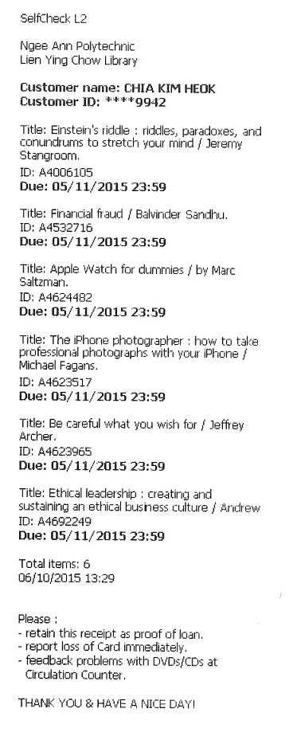

**Appendix B – Uniqlo Sales Receipt**

